**DEPARTMENT OF COMPUTER TECHNOLOGY**

## MADRAS INSTITUTE OF TECHNOLOGY

**CS6110 OBJECT ORIENTED DESIGN AND ANALYSIS**

**MINI PROJECT**

**PAC-MAN GAME**

**SOFTWARE REQUIREMENT SPECIFICATION DOCUMENTATION**

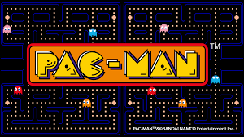

MENTOR: Dr. S. Neelavathy Pari

BY:

Kartikeyan TR - 2020503520

Suriyaa V - 2020503550

Guru Raman C - 2020503510

INDEX

1.Problem4

1.1 Problem Statement4

1.2 Objectives4

2.SOFTWARE REQUIREMENT SPECIFICATION5

**2.1** **Introduction**

2.1.1 Purpose5

2.1.2 Scope 5

2.1.3 Intended Audience5

2.1.4 Overview 5

2.1.5 References 6

2.2 Overall Description6

2.2.1 Product Functions6

2.2.2 Operating Environment7

2.2.3 User Documentation7

2.2.4 Assumptions & Dependencies 7

2.3 Specific Requirements7

2.3.1 Functional Requirements7

2.3.2 Non-Functional Requirements8

2.3.3 External Interface9

3.USE CASE DIAGRAMS10

4.CLASS DIAGRAMS13

5.SEQUENCE DIAGRAM14

6.ACTIVITY DIAGRAM15

7.STATE DIAGRAM16

8.COMMUNICATION DIAGRAM17

9.COMPONENT DIAGRAM18

10.PACKAGE DIAGRAM19

11.DEPLOYMENT DIAGRAM20

**1.Problem**

1.1 Problem Statement:

Designing a game Pac-man to be played by one player where a player can sit and get engaged physically and mentally. Making various modifications to the game UI such as game theme and player avatar and the game maze

1.2 Objectives:

* To create a game using OOPS concepts
* Analyze various game algorithms
* To understand OOAD concepts better
* To create an interactive GUI
* To implement proper software design methodologies [70% design and 30% implementation]

**2.SOFTWARE REQUIREMENT SPECIFICATION**

**2.1 Introduction**

**2.1.1 Purpose**

The main purpose of this project is to create a PAC-MAN game using the OOAD concepts in JAVA (a OOPs language).

**2.1.2 Scope**

The software is application called Pac- man. It can used to play the retro-famous PAC-MAN game.

The application will also allow users to modify their avatar in the game and also change the theme of the game.

The application is meant for users who would like to play the PAC-MAN game but in a different style. ­­

**2.1.3 Intended Audience**

The intended audience of this document would be pre teenage children. The SRS document can be used in any case regarding the requirements of the project and the solutions that have been followed. The document would finally provide a clear idea about the system that is being built.

**2.1.4 Overview of Game**

PAC-MAN is an action maze chase video game; the player controls the eponymous character through an enclosed maze. The objective of the game is to eat all of the dots within the given timer that are placed in the maze while avoiding four colored ghosts. The player with the maximum points tops the leaderboard.

**2.1.5 References**

IEEE. IEEE Std 830-1998 IEEE Recommended Practice for Software Requirements Specifications. IEEE Computer Society, 1998.

**2.2. Overall Description**

**2.2.1 Product Functions**

This is the game so its most important function is that it is a source of entertainment.

**2.2.2 Operating Environment**

* This application (Game) is operated as an windows application.
* The application can be run as an application or also in browser.

**2.2.3 User Documentation**

The control scheme of the PAC-MAN game same as in the original PAC-MAN game. The controls are simple and user will be able to learn it within minutes.

* There will be a PAC MAN named sprite which will move in according to directions given by us.
* PAC-MAN will eat dots and there will be a score board which will show the number of dots eaten.
* PAC-MAN will have to survive against the enemies who will move randomly in the tunnels.
* When level will be completed next level would come.
* There would be 3-4 levels of the game which will have different type of mazes. To make game more excited we shall make 3 lives of PAC-MAN.
* Score, levels and lives will be visible on the screen.
* There will be buttons on screen to control some actions of game.
* There will be background sound of PAC-MAN Game.
* There will be all of the features of an arcade game.
* There will be a High Score board which will be shown when game will end.
* There will be tunnel through which PAC-MAN can pass walls and can appear from the other side.

**2.2.4 Assumptions and Dependencies**

We assume that the user has an windows operating system installed in his/her PC.

**2.3 Specific Requirements**

**2.3.1 Functional Requirements**

The following were the functional requirements identified:

* The system offers a graphical user interface (GUI) that allows a player to attempt to complete a challenge as a game, the challenge is to locate all hidden objects to be eaten in the visual representation of the environment
* The system should enable a menu-item option for the player to select different difficulty levels. The levels consist of larger environments of the same type. The density of the game levels in an environment must be roughly the same across difficulty levels.
* The system should enable a menu-item option for the player to select a different environment There should be 3 environments: a square-grid, hexagonal grid, and a graph layout.
* The system should display a timer in seconds. Starting the game starts the countdown of the timer. The game does not end if the timer expires
* The system should display the total number of food available requiring localization in the environment output.

**2.3.2 Non-Functional Requirements**

* **Performance** – Since game is light-weight the performance will be good even in a low spec PC.
* **Safety** – The game occupies only about 30mb of RAM. So the game will no overheat and wont cause damage to the hardware in which it is being played.
* **Security** – The game doesn’t collect any personal data. All the data are actually being locally stored in the computer so no data leak is possible.
* **Software Quality –** The game runs without any frame drop even in low-end laptop. Since the application is light-weight, the performance will be solid. Also the game refreshes at a rate equal to the screen refresh-rate of the computer so there will not be any response delay in the software side although the response time mainly depends on the hardware.

**2.3.3 External Interface**

**3.3.1 Hardware Interfaces**

|  |  |
| --- | --- |
| Hardware Environment | Any OS |
| System Configuration | 8 GB RAM and 256 GB storage |
| Operating System | Windows 10/11 |

**3.3.2 Software Interfaces**

|  |  |
| --- | --- |
| Front End | Java |
| Back End | Java, SQL |

5.USE CASE DIAGRAM

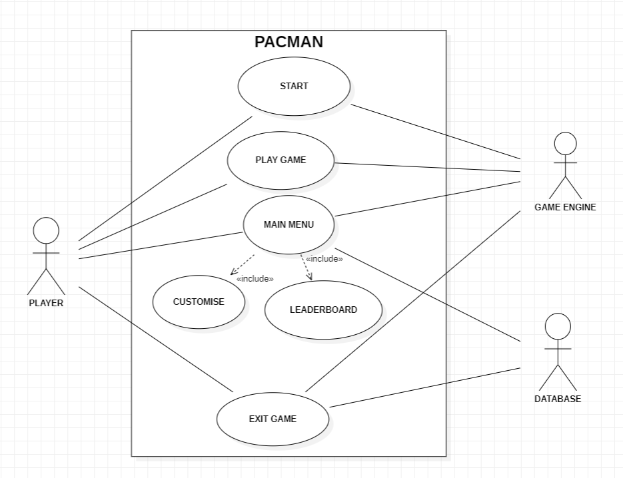

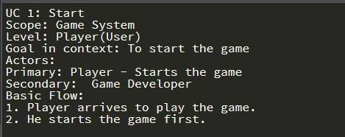

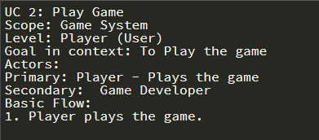

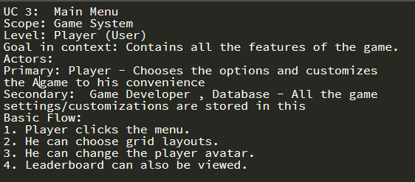

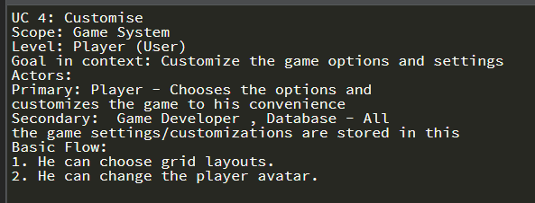

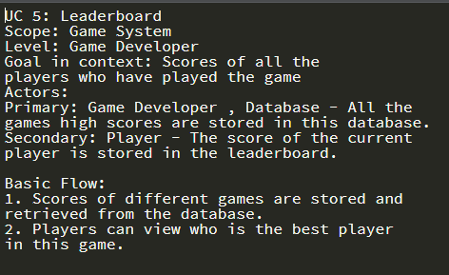

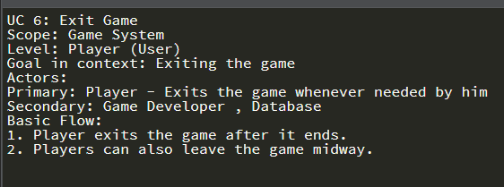

6. CLASS DIAGRAM

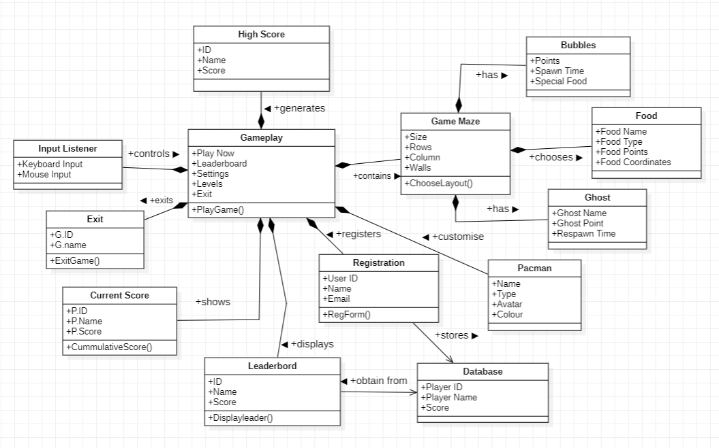

7.SEQUENCE DIAGRAM

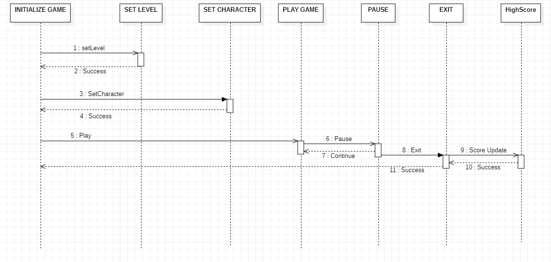

8.ACTIVITY DIAGRAM

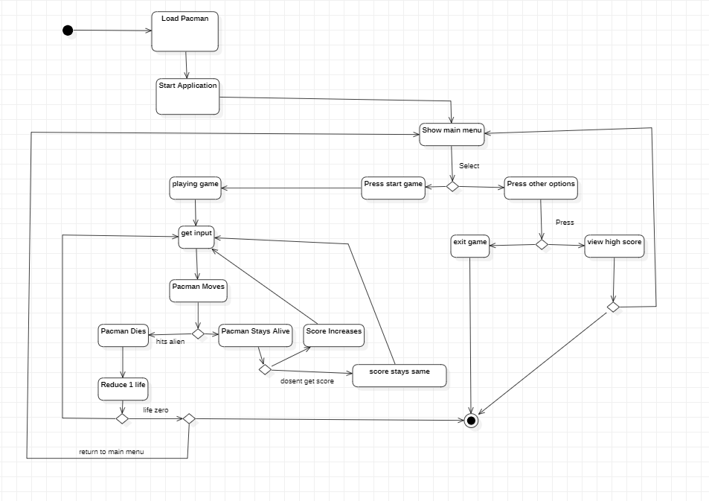

9.STATE DIAGRAM

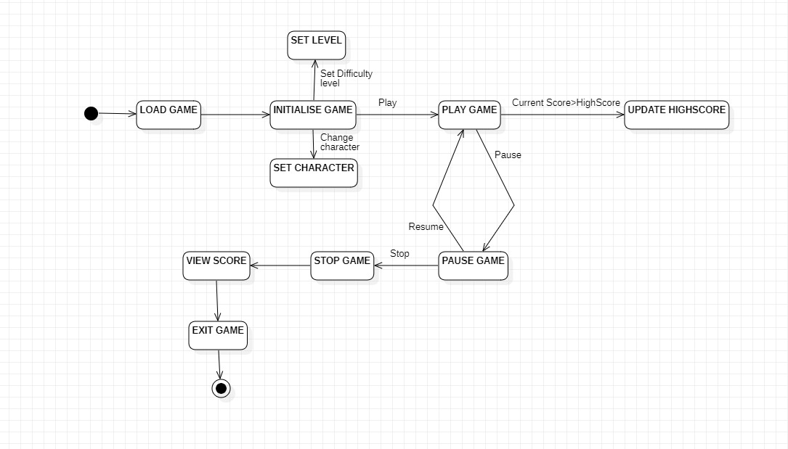

10.COMMUNICATION DIAGRAM

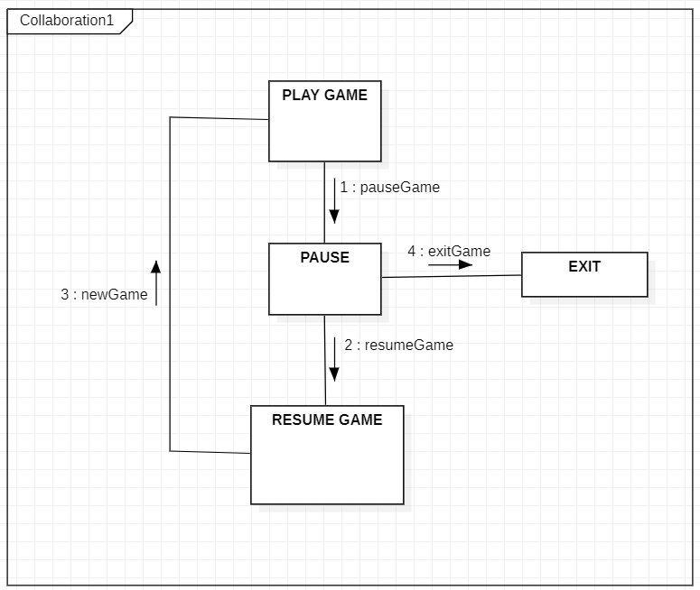

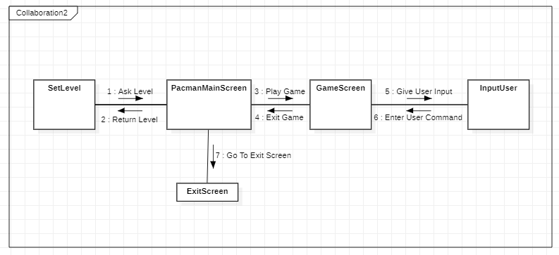

11.COMPONENT DIAGRAM

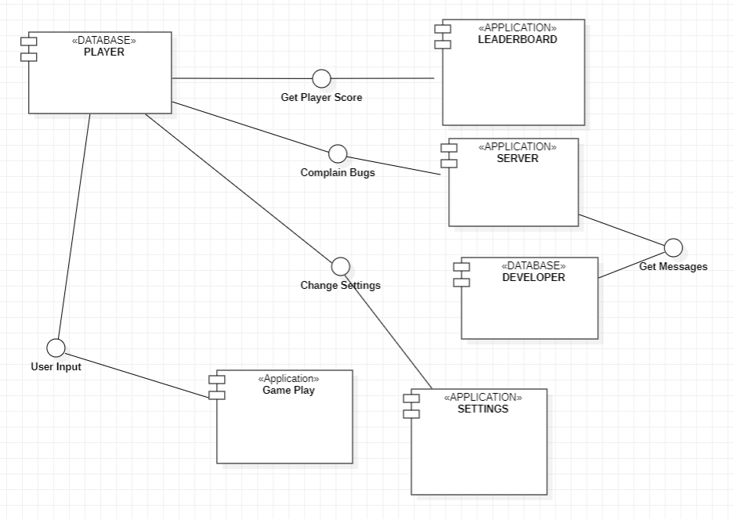

12.PACKAGE DIAGRAM

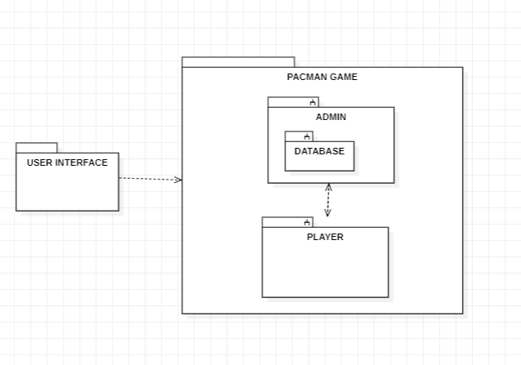

13.DEPLOYMENT DIAGARM

